**Overview**

In this exercise, you will configure the setup for migrations of the UbuntuWAF, SmartHotelWeb1, SmartHotelWeb2 & SmartHotelSQL1 VMs in Hyper-V into Azure.

The migrations will take place using Azure Migrate.

**Setup Azure Migrate as below**

In this exercise you will migrate the web tier and application tiers of the application from on-premises to Azure using Azure Migrate: Server Migration.

1. Storage account:-

Storage Account:- thomashypervmigrationsa already created via Terraform in resource group

1. Virtual Network

Virtual network:- landing-zone-migration created via Terraform

1. Enable replication from hyper-v to Azure Migrate

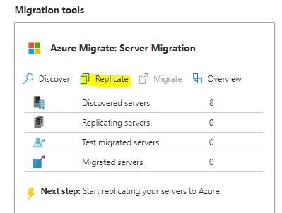

In the **Source settings** tab, under **Are your machines virtualized?**, select **Yes, with Hyper-V** from the drop-down. Then select **Next: Virtual machines**.

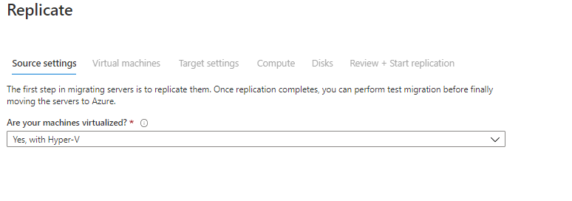

For this exercise, do not specify assessment

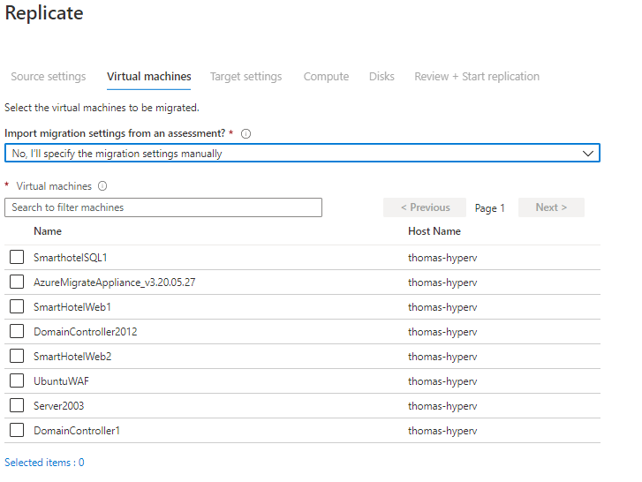

Select Application VMs you want to migrate

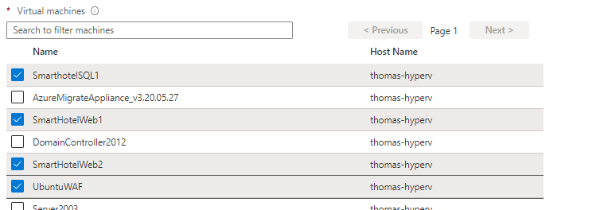

Configure target settings as below

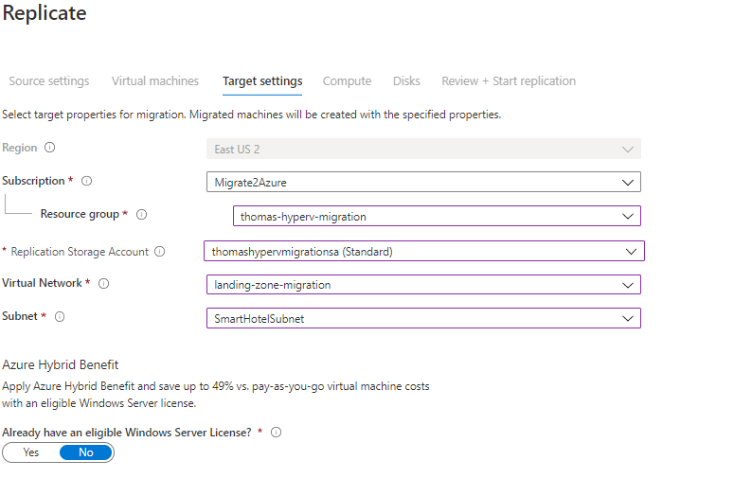

Replicate settings as below (B2s for this exercise to reduce cost)

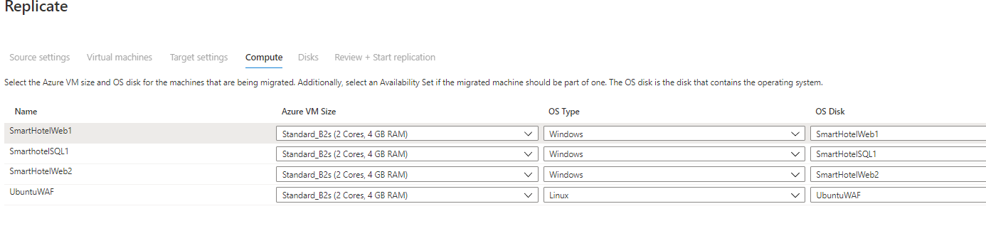

Disk settings (all)

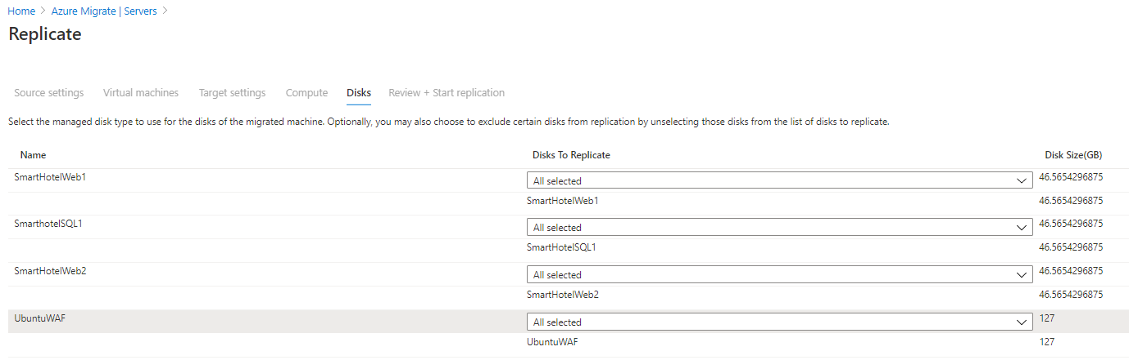

**Tasks**

1. Setup each of the 4 Servers to replicate from Hyper-V host into Azure
   1. Ensure all VMs go into Azure Virtual Network:- **landing-zone-vnet** & its relevant subnet (SmartHotelweb1subnet etc, desired subnet is relevant to the name of VM)
   2. Ensure all VMs have a Static private IP configured prior to migration
   3. Storage account already created via Terraform in resource group
2. Review NSG and confirm it is configured ready for migrations to begin
3. Ensure all VMs on hyper-v host which you are migrating are accessible via RDP/SSH from Hyper-V host

**Exercise targets**

1. Setup of each of the 4 servers in Azure Migrate
   1. All with correct Azure Virtual Network Setup
   2. All having Static Private Ips
   3. All to be fully protected and confirmed
2. NSG/ASG review & confirm migration is ready
3. Ensure all VMs on hyper-v host which you are migrating are accessible via RDP/SSH from Hyper-V host